Working paper. Do not cite. Comments are welcome.

FRAMING THE NEWS: AN ETHNOGRAPHIC VIEW OF FINANCIAL NEWSWRITING

Tom Van Hout & Felicitas Macgilchrist

ABSTRACT
This paper tracks the newsmaking process from the initial entry of a story into the newsroom (in the form of a press release) through the meso-level process of editorial decision-making (in the form of story meetings) and the micro-level process of re-writing to the ''final'' output articulated for the consumers of financial news. Whereas previous studies of journalism have tended to focus on either news texts or news processes (cf. Zelizer 2004), this paper analyses both the textual and process aspects of news-writing. These discursive practices are investigated by adopting a research methodology which combines frame analysis (Gamson & Modigliani 1989), participant observation (Cottle 1998) and writing process analysis (Perrin 2006). Analyzing the frames in the source text, we examine to what extent journalists draw on the frames to pitch their story to the copy desk chief, while keystroke logging data and retrospective interviews allow us to reconstruct and interpret the writing process in detail. In a final analytical move, the published news story frames are compared to the original text. The case study we present here is drawn from ethnographic research on newsroom practices at a Flemish quality newspaper and suggests how an understanding of journalistic practices aids the analysis of news production.

Author contact details:

Tom Van Hout
Ghent University
tom.vanhout@ugent.be

Felicitas Macgilchrist
European-University Viadrina, Frankfurt/Oder
macgilchrist@gmx.net

1. Introduction

This paper focuses on the discursive practices of a business reporter as he discovers, negotiates, writes and reflects on a news story. We thus “follow the story” (Boyer & Hannerz 2006: 13) from the story entry in the newsroom through the review process during a story meeting and the writing process itself. Introducing an innovative method combining frame analysis, newsroom ethnography and computer-assisted writing process analysis, our data shed light on the discursive transformations that lie at the heart of the news production process.
News production is seen here as a form of reproductive writing (Jakobs 2003) involving the transformation of multiple news discourses (press agency copy, press releases, interview notes, other news media) into a single narrative, framed as an authoritative account of a news event. This view highlights the intertextuality of news sources and news texts. Intertextuality is used here first and foremost to refer to the ways in which information is linked to sources. Case in point is the genre of press releases. These texts are typically “prefabricated in an appropriate news style” (Bell 1991: 58) to facilitate reproduction in and by the media. These ‘preformulation’ features are discussed at length in Jacobs (1999) and include the use of newspaper-like headlines, narrative structure and a number of metapragmatic features, most prominently third person self-reference (“J.P. Morgan announced today” instead of “we”) and pseudo-quotations (“Fortis Bank CEO John Sheffield noted that ‘the merger signifies a major step forward’…”). In addition to having a textual dimension, intertextuality can also be seen as “a strategically deployed [social] practice through which producers […] construct meanings, frame activities and pursue outcomes" (Peterson 2001: 239). Viewed as such, news production becomes a process of entextualization (Bauman & Briggs 1990; Briggs & Bauman 1992; Silverstein & Urban 1996), i.e. the extraction (decontextualization) of source material and its subsequent insertion (recontextualization) into news discourse. In attempt to illustrate this process of entextualization, we present a case study documenting how a senior business reporter discovers a story, introduces it into the newsroom, writes a news story and reflects on it.

2. Method

We propose a combination of frame analysis, newsroom ethnography and computer-assisted writing process analysis. Frames are understood as those ‘principles of selection, emphasis, an presentation composed of little tacit theories about what exists, what happens and what matters’ (Gitlin 1980: 6). Comparing the frames in the source texts and the final published news story enables us to investigate which sources have the authority to produce versions of knowledge which ‘frame’ public understandings of events. Using participant observation (Cottle 1998) and interview data, we contextualize how journalists write news stories (see Sleurs & Jacobs 2005 for a pilot study on writing press releases) within the institutional context of a newsroom. These ethnographic data are complemented by online writing process data in the tradition of cognitive psychology (MacArthur, Graham & Fitzgerald 2006). To this end, two software applications were used: Inputlog and Camtasia Studio. Inputlog is a Microsoft Windows based logging tool which records keyboard strokes and mouse movements and generates datafiles for statistical, text, pause and mode analyses (Leijten & Van Waes 2006). Camtasia Studio is an online screen registration tool which we used to make screenvideos of the observed writing processes. These files enabled easy and immediate playback of the recorded writing process data during retrospective interviews. Both applications were used to record, reconstruct and analyze writing processes.

3. Data

Our data are drawn from a larger, ethnographic study of journalists’ reproductive newswriting practices. Fieldwork was conducted between October 2006 and March 2007 at the business newsdesk of a major Flemish quality newspaper by the first author of this paper. The case study reported on here was selected because it provides a rich context for analyzing the situated practices of a senior business reporter who we will call AMT. We were told in an interview with copy desk chief LRN that AMT was ‘a reporter pur sang’, an acknowledgement of AMT’s wide interest in and coverage of business news. During my fieldwork, AMT was promoted to assistant business editor and he won a professional award for journalistic excellence.
The news story we follow (henceforth: the VIB story) is concerned with increased government funding of biotechnology and nanotechnology research. Two prestigious Flemish research institutes, VIB and IMEC have been awarded new research contracts by the Flemish government. This event was not listed in the newsroom’s ‘story budget’; i.e. it was not a planned story. Instead, the event was brought to AMT’s attention by a spokesperson for the Flemish Minister of Science who had called AMT to announce a press conference later that day and to ask if he was planning to attend. Hearing that AMT was not going to attend, the spokesperson then informed him that a press release would be sent round and that the presentation slides used during the press conference were also available. Sensing a good story, AMT inquired about the increased funding and accepted the spokesperson’s offer. AMT mentioned in an interview that the spokesperson had called him “because he had seen around me a couple of times at press conferences.”

3.4 Results

In this section, we present a transcript of the story meeting detailing story introduction and assignment as well as selected writing process and retrospective interview data. We start by setting the scene.

Setting the scene

AMT received the VIB press release in his inbox along with several others (suppressed) recipients at 2:33pm. 26 minutes later, AMT received a personal email message from the Flemish Minister of Science and Innovation office. The message referred to AMT’s telephone agreement with the spokesperson and came with two attachments: the VIB press release and the presentation slides. The analyses are based on the original Dutch texts but, since an official English language translation was available on the VIB website, the official English translation will be used for reference and illustration (cf. handout).

Story meeting

The story meeting provides a forum for introducing, reviewing, selecting, following up on and assigning developing stories for next day’s paper (see also Clayman & Reisner 1998). During these daily staff meetings, story length is decided, potential cover stories are discussed and general announcements are made. The meeting is attended by all the business reporters who are in that day, the desk chief and one or two copy-editors. It is chaired by desk chief LRN who also makes the ‘story budget’, a list of possible stories based on the newsroom agenda, incoming press releases, news agency copy and other media.
An audio recording of the story meeting is transcribed according to conversation analytic conventions. Analysis is based on the original Dutch transcriptions, which have, however, been translated into English to accommodate a wider audience. The English transcriptions provide an idiomatic translation of the Dutch original, which can be found in the appendix to this paper. The transcript is first presented in full, followed by a discussion of arrowed lines.

Participants:

GRI reporter
ONL reporter
TRE reporter
AMT reporter
HOM reporter
LRN desk chief
HOB reporter
TRA copy editor

“there’s also erm” (DS_W16_D4_eco_10’12”)

 | TRE: | Pieter- xxx Pieter on his cartoons xxx
 | AMT: → | there’s also erm-
 |  | (laughter)
 | HOM: | gosh, are you already doing that now?
 | GRI: | yeah, that’s incre[dible that xxx that’s going to become a xxx or something
 | AMT: → | [the signing of the new management agreement between the Flemish government and erm the V I B and IMEC they’re getting 20% [more money
 | GRI: | [what? two months?
 | TRE: | Three
 | GRI: | three months and he’s already putting him in front of the [tv]?
 | ONL: | [woohahaha]
 | AMT: → | [should attention be paid to this?]
 | LRN: → | [60 line-] 60 lines on eco 4, no? if they get more money
 | AMT: → | yes 20 procent [xxx]
 | TRE: | [xxx]
 | TRA: → | what’s that AMT, the Flemish government and?
 | AMT: → | v i b and Imec are getting more money
 | HOM: | from Fientje?
 | AMT: | from Fientje
 | LRN: | that’s biotechnology [and (1.1)
 | HOB: | [xxx so biotechnology]
 | LRN: | (jokingly) c’mon, you still don’t know this? goddammit??? time and again I’ve xxx

As the transcript begins with some playful banter about parenting between TRE, HOM and GRI, AMT tries to address LRN (line 245) but his initial attempt drowns in group laughter. In line 249, AMT mentions the VIB story by first referring to the pseudo-event of the signing of the agreements and then by adding the more newsworthy detail of the budget increase.

 | AMT: | [the signing of the new management agreement between the Flemish government and erm the V I B and IMEC they’re getting 20% [more money

This double-edged pitch offers a first glimpse at how AMT (re)entextualizes the VIB story: shifting into a more formal, nominal register typical of story summaries, AMT echoes the opening line of the VIB press release: “Today Flemish Minister for Science and Innovation Fientje Moerman has [sic] signed the new management agreements (2007 – 2011) for VIB and IMEC.” Apparently, AMT employs preformulation socially to promote the VIB story to LRN. The notion of preformulation (Jacobs 1999) was hitherto conceived of as primarily a textual property of press releases. This excerpt however, illustrates how it can also be used in social interaction: to pitch a news story to the desk chief. Next, AMT drives his story promotion home by referring to the scale of the financial event involved; a 20% budget increase is a significant – and hence newsworthy – event. Again, this resonates the language of the press release: “The budget of operation of both institutes increases with 20%”. It should be noted that AMT does not attribute the source, nor mention the actor involved, namely the Flemish minister of Science, Fientje Moerman. By doing this, AMT claims authorship of the story.
A very brief negotiation between AMT and LRN ensues (lines 266-8), in which AMT asks if this story should be run. The passive voice construction in line 266 functions as a sort of authorship hedge, illustrating the supply and demand mechanism of story meetings.

 | AMT: | [should attention be paid to this?]
 | LRN: | [60 line-] 60 lines on eco 4, no? if they get more money
 | AMT: | yes 20 procent [xxx]

LRN immediately assigns AMT 60 lines on page four of the business section but asks AMT for confirmation of the budget increase. This conditional reiterates the implicit newsworthiness assessment of AMT’s story promotion, which AMT confirms. AMT expresses the scale of the budget increase in relative terms (“20%”) and not in absolute terms (“400 million euro”), thus emphasizing the ratio of the increase and not the amount of money involved.
At this point, the copy editor, who’s sitting at the other end of the conference table overhears the discussion and asks AMT for clarification as she writes in a notebook. AMT reiterates the appeal to newsworthiness (line 270):

 | TRA: → | what’s that AMT, the Flemish government and?
 | AMT: → | v i b and Imec are getting more money
 | HOM: | from Fientje?
 | AMT: | from Fientje

This triggers HOM to inquire about the agent involved (line 271). AMT confirms that it is Fientje Moerman, currently Flemish minister of science and formerly a newsroom colleague of the business staff. AMT later told me that he never worked with Fientje but that HOM did.
By focusing on agency in the immediate context of a story meeting, this short excerpt illustrates how AMT introduces the VIB story into the newsroom by resonating the pseudo-event and title of the press release. This is what Mark Peterson calls the interpretive practice approach to media production: “the detailed description of the acts through which media texts are negotiated […] Such an approach allows us to examine creativity and interpretation as they are played out in both the social and textual dimensions […] This approach assumes that interpretive creativity is not random but constituted by and constitutive of social heuristics and cultural epistemologies” (2003: 184). The heuristics and epistemologies AMT employs in his story promotion are an authoritative voice (nominalization), the assumption of authorship (absence of source attribution), deictic reference to newsworthiness (budget increase, in relative terms and not absolute terms) and the suggestion of journalistic presence, “based on having ‘been there’ so that [AMT] can ‘report it’” (Peterson 2003: 77). Crucially, the employment of these heuristics and epistemologies should be seen in the context of a social field in which reputations, power and professional statuses are at stake.

Writing process

In AMT’s newspaper article, all intertextual links to news sources are rendered implicit. This is a common practice in news journalism; by concealing news sources – referencing at best to the source text in the form of a trope like “according to a statement issued by the company” – as well as their own actions for obtaining the information reported on, reporters assume authorship and thus establish journalistic authority. Our process data allow us to foreground these intertextual links by looking at the writing process in detail and seeing where and how AMT draws on source material. For these purposes, we draw on writing process data as well as screen video, interview and product data. One way of visualizing these intertextual links is to plot the writing process in an activity graph. Perrin (2003) distinguishes two meso level actions in the “writing progression” of journalists: text insertion and deletion. These actions constitute revisions. We use a similar approach: figure 2 graphically represents AMT’s writing process by plotting temporal data (in absolute time) against process data, i.e. keyboard strokes (the number of revisions) and mouse

Figure 2. Activity graph of VIB writing process

commands (movement and clicks). This graph is based on a five second period, linear log file generated by Inputlog. The graph shows 4 distinct phases in AMT’s writing process: a preparatory phase (0’00”-7’00”), two text construction phases (7’00”-16’01” and 17’02”- 24’03”) and a revision phase. The preparatory phase consists of mouse movements (scrolling through emails and opening attachments), while the text construction phases show a high number of keyboard movements (text insertion and deletion) as well as mouse movements (cursor movement, switching and resizing computer windows, looking for online information). During the revision phase AMT revises and edits his text, switching back and forth between the preview pane and the editing window. A screenshot is given by way of illustration (Figure 3).
As regards AMT’s sourcing practices, the process data show that AMT draws on two sources: the press release issued by the Minister of Science and the powerpoint slides used during the press conference. The former AMT prints out and places on his desk, the latter he opens in a text editing window. A screenshot taken from the video data illustrates this setup (Figure 4). AMT’s use of sources largely overlaps with the two main text construction phases: information from the press release was used to write the headline, lead and background information about the research institutes during the first text construction phase, while the powerpoint slides were used to write the concluding paragraphs on government demands and agreement types during the second text construction phase (a translation of the news article can be found in the Appendix).
Crucially, this illustrates how and where preformulation ‘works’: apparently, preformulated texts allow journalists to write quickly, and thus save time. The fact that AMT largely retells preformulated information partially accounts for AMT’s highly routinized and linear writing process (cf. infra). In addition, we would also like to underline AMT’s use of the presentation slides. Indeed, much like the press release, AMT draws on these slides to write about the requirement of a new corporate governance policy and performance indicators. By doing so, AMT assumes authorship of the information drawn from both sources and thus falsely taking credit for having been at the press conference. During the retrospective interview, AMT commented that overt source attributions such as ‘according to an official statement’ are “rather useless” and that he makes a point of not mentioning them. However, in his news article, AMT refers to the “new management agreements which were signed yesterday by the Minister of Science and Innovation Fientje Moerman…”. Commenting on why he refers explicitly to this pseudo-event, AMT said “well, there was a press conference, so it would be weird not to write that”. This statement not only provides evidence for a conscious decision on AMT’s part but it also provides support for Peterson’s claim that journalistic authority is based on ‘having been there’. AMT’s journalistic authority is built on his concealment of the two preformulated news sources - which happened to fall on his lap – without his having to attend the press conference.
If we then look at some descriptive statistics of the writing process (Table 1), there is a strikingly small difference between process and product data: differentials of 274 characters and 43 words are low when compared to similar writing from (multiple) sources tasks (O'Hara et al. 2002). With a total production time of 9’22” and a pause time of 24’02 (including reading time), these numbers indicate a very linear and thus routine writing process. In those 9 minutes of text production, AMT is very productive: not only does he write the article manually – he does not copy/paste text from the slides – he also double checks information online.

VIB story | process | product | differential
Total number of characters | 1718 | 1444 | 274
Total number of words | 281 | 238 | 43
Production time (in minutes) | 9.22 | / | /
Pause time (in minutes) | 24.02 | / | /
Total duration of writing process (in minutes) | 33.24 | / | /
Table 1. Descriptive statistics of VIB writing process

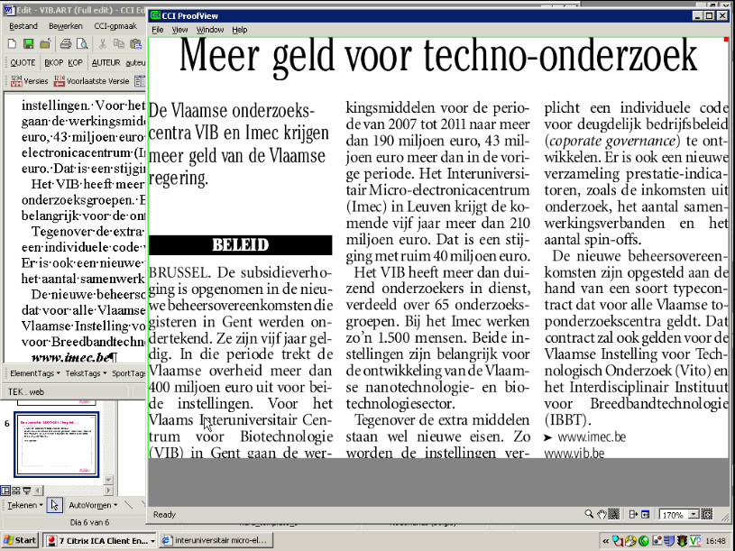
Figure 3. Screenshot of preview pane

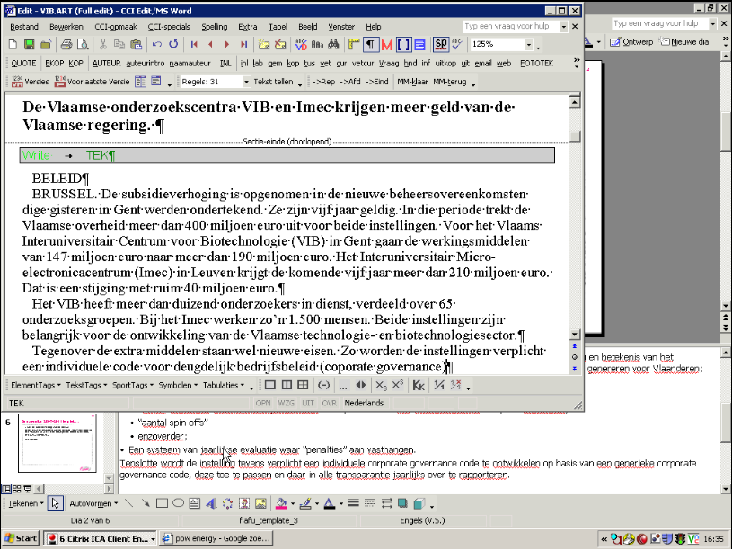
Figure 4. Screenshot showing backgrounded presentation slide and text editing window

Interestingly, if we look for pause length in the writing process, we find that the mean pause time is 4.344 seconds (with a standard deviation of 7.734 seconds). While a full-fledged analysis of the pausing behavior is beyond the reach of this paper, we would like to conclude this part with a brief example of AMT’s pausing behavior in relation to his sourcing practices. In order to visualize the writing process, Inputlog generates linear logs of recorded writing sessions. If we look at how AMT writes the opening sentence, the linear log looks like this:

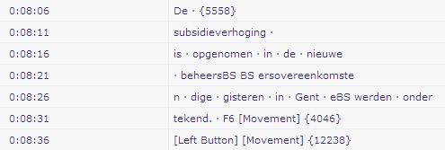
Figure 5. Linear log passage

This fragment shows a very fluent writing process, typical of the sort of highly routinized behavior that writing from sources is for business journalists. The fragment also shows the effects of preformulation: AMT rewrites the opening line of the press release from:

“Today Flemish Minister for Science and Innovation Fientje Moerman has [sic] signed the new management agreements (2007 – 2011) for VIB and IMEC.”

to

“The subsidy raise is included in the new management agreements which were signed yesterday in Ghent.”

AMT thus foregrounds the budget increase. In the linear log, we see a 5 second pause (5558 milliseconds) before AMT writes “subsidieverhoging” (Eng. subsidy raise). This hesitation is a direct result of AMT’s reliance on the press release, which does not mention the term ‘subsidy raise’. This hesitation is significant, because AMT does not pause when he writes the rest of the opening sentence. The typographical error at the 08’21” mark he corrects directly. He then switches to the preview pane (F6). During the revision phase toward the end of his writing process, the spelling error in the Dutch relative pronoun “die” (Eng. that) is corrected at the 26:53 mark.

Framing

The hesitation, therefore, indicates a frame shift. The previous extracts indicate that when AMT shifts the focus (i.e. to return to Gitlin’s phrase (1980: 6), ‘what matters’) away from the press release, a pause is logged. Nevertheless, overall he takes the predominant press release frames on board, thus enabling his short production time. Without going into an elaborate frame analysis at this stage, the VIB press release and presentation prioritize three frames for the events: (i) cooperation (‘management agreements’), (ii) employment (‘IMEC plans more than 100 new recruitments’) and (iii) efficiency (‘performance indicators’, rather than research for the sake of increased knowledge).

In AMT’s transformation of the two sources into one news story, he retains (i) the cooperation frame in the use of the same term ‘management agreements’ and (ii) the employment frame (‘VIB employs more than 1,000 researchers, divided over 65 research units. Around 1,500 people work at Imec’). He does not, however, describe the increases in efficiency as entirely beneficial to all sides. Where the presentation slides announce an ‘integrated approach’ with clear benefits, AMT introduces the approach with ‘The extra funds come with new demands’, which the institutions are ‘required’ to fulfill. With these two simple lexical items – demands and required – AMT introduces, albeit subtly, an alternative media frame which questions the legitimacy of attaching research funding to efficiency goals.

4. Conclusion

Drawing on fieldwork data, this paper highlighted selected practices of a senior business reporter as he discovers, negotiates, writes and files a news story. By focusing on the role of source media (i.e. press releases) and the journalist’s interpretive practices in newswriting, we outlined how the discursive transformations shed light on journalists’ writing practices. We believe that the analysis of the social and textual practices surrounding the use of source media in newswriting offers many exciting avenues for further research on news production. Or as Gaye Tuchman writes: "At the juncture between sources and reporters, 'source media' (press releases, government reports, telephone interviews, etc.) provide important and still under-researched raw material for what ends up as news texts" (2003: 89).
Our combined methodology of frame analysis, newsroom ethnography and computer-assisted writing process analysis offered a behind-the-scenes look at the situated practices of news production. Moreover, it was shown that, in addition to having a textual function, preformulation is used socially to promote a news story during story meetings and that the reliance on press releases allows for a linear, routine writing process.

Over the years, a fully-fledged industry of frame analysts, each competing to present the definitive definition of ‘frame’ and ‘frame analysis’, has developed. For an overview, see (Fisher 1997; de Vreese 2005)
Inputlog is freely available to the research community at the following website: http://webh01.ua.ac.be/mleijten/inputlog/
For more information and download options, see http://www.techsmith.com
The English language press release is available here: http://www.vib.be/NR/rdonlyres/17268A44-2198-459B-A50F-AA4B6E869151/2244/20070308_ENG_VIB_managementagreement.pdf Appendix VIB news article (English translation) More money for techno research Policy news Flemish research institutes VIB and IMEC to receive more money from the Flemish government. BRUSSELS. The budget increase is included in the new management agreements which were signed yesterday by the Minister of Science and Innovation, Fientje Moerman (Open VLD). They are valid for five years. During that time the Flemish government will shell out more than 400 million euro for both institutions. For the Flemish Interuniversity Center for Biotechnology (VIB) in Ghent, the funds for the period between 2007 and 2011 will go upwards of 190 million euro, 43 euro million more than during the previous period. Over the next five years, the Interuniversity Microelectronics Center (Imec) in Leuven will be receiving more than 210 million euro, a boost of more than 40 million euro. VIB employs more than 1,000 researchers, divided over 65 research units. Around 1,500 people work at Imec. Both institutes are important for the development of the Flemish nanotechnology and biotechnologysector. The extra funds come with new demands. The institutions are required to develop new individual codes of proper management (corporate governance). There is also a new list of performance indicators such as total revenue from research, the number of joint ventures and the number of spin-offs. The new policy agreements have been drawn up using a sort of modelcontract, valid for all Flemish top-level research institutes. This contract will also be valid for the Flemish Institute for Technological Research (Vito) and the Interdisciplinary Institute for Broadbandtechnology (IBBT). (amt) References Bauman, Richard and Briggs, Charles L. (1990). Poetics and Performance as Critical Perspectives on Language and Social Life. Annual Review of Anthropology 19, 59-88. Bell, Allan (1991). The Language of News Media. Oxford: Blackwell. Boyer, Dominic and Hannerz, Ulf (2006). Introduction: Worlds of journalism. Ethnography 7, 5-17. Briggs, Charles and Bauman, Richard (1992). Genre, intertextuality, and social power. Journal of Linguistic Anthropology 2. Clayman, Steven and Reisner, Ann (1998). Gatekeeping in Action: Editorial Conferences and Assessments of Newsworthiness. American Sociological Review 63, 178-199. Cottle, Simon (1998). Participant Observation: Researching News Production. In Anders Hansen, Simon Cottle, R. Negrine and C. Newbold (eds.), Mass Communication Research Methods 35-65. Basingstoke: Macmillan. de Vreese, Claes H. (2005). News framing: Theory and typology. Information Design Journal + Document Design 13, 51-62. Fisher, Kimberley (1997). Locating Frames in the Discursive Universe. Sociological Research Online 2. Gamson, William A and Modigliani, Andre (1989). Media Discourse and Public Opinion on Nuclear Power: A Constructionist Approach. The American Journal of Sociology 95, 1-37. Gitlin, Todd (1980). The Whole World is Watching: Mass media in the making and unmaking of the new left. Berkley: University of California Press. Jacobs, Geert (1999). Preformulating the news. An analysis of the metapragmatics of press releases. Amsterdam: John Benjamins. Jakobs, Eva-Maria (2003). Reproductive writing - writing from sources. Journal of Pragmatics 35, 893–906. Leijten, Mariëlle and Van Waes, Luuk (2006). Inputlog: New perspectives on the logging of on-line writing processes in a windows environment. In K. Sullivan and E. Lindgren (eds.), Studies in Writing: Vol. 18. Computer Key-Stroke logging and Writing. Methods and Applications 73-94. Oxford: Elsevier. MacArthur, C. A., Graham, S. and Fitzgerald, J. (eds.) (2006). Handbook of writing research. New York: Guilford. O'Hara, K. P., Taylor, A., Newman, W. and Sellen, A. J. (2002). Understanding the materiality of writing from multiple sources. International Journal of Human-Computer Studies 56, 269-305. Perrin, Daniel (2003). Progression analysis (PA): investigating writing strategies at the workplace. Journal of Pragmatics 35, 907-921. Perrin, Daniel (2006). Progression Analysis: An Ethnographic, Computer-Based Multi-Method Approach to Investigate Natural Writing Processes. In Luuk Van Waes, Mariëlle Leijten and Chris Neuwirth (eds.), Writing and Digital Media Oxford: Elsevier. Peterson, Mark Allen (2001). Getting to the Story: Unwriteable Discourse and Interpretive Practice in American Journalism. Anthropological Quarterly 74, 201-211. Peterson, Mark Allen (2003). Anthropology & Mass Communication. Media and myth in the new millenium. New York: Berghahn Books. Silverstein, Michael and Urban, Greg (eds.) (1996). Natural Histories of Discourse. Chicago: University of Chicago Press. Sleurs, K. and Jacobs, G. (2005). Beyond preformulation: an ethnographic perspective on press releases. Journal of Pragmatics 37, 1251-1273. Tuchman, Gaye (2003). The production of news. In Klaus Bruhn Jensen (ed.), A Handbook of Media and Communication Research: Qualitative and Quantitative Methodologies 78-90. London: Routledge. Zelizer, Barbie (2004). Taking Journalism Seriously: News and the Academy. Thousand Oaks: Sage.

